Supplementary Materials
  - Children’s Expectations of Emotional Intimacy in Close Relationships
2026-06-30
This document is reproducible: every table and figure is produced by 5. Analysis/code/OMIT_CLEAN.R and read here via here().

1. Supplementary Methods

1.1 Participants
Full sample sizes and age/sex breakdowns are given in the main text. Briefly, the Set-A studies (Studies 1, 3A, 4A) tested 57 children (6–9 years) and 47 adults; the Set-B/C studies (Studies 2, 3B, 4B) tested 105 children and 49 adults.

1.2 Sample-size justification
For the Set-B/C studies we pre-registered a target of 56 children, consistent with prior work that detected comparable effects (Woo et al., 2024). However after we had tested 56 children we analyzed the data and the results were inconclusive. Thus we decided to collect double the amount which is allowed when using bayesian analyses (Wagenmakers et al., 2019) Recruitment exceeded the target, yielding 105 children. Adult comparison samples (47 and 49) were collected via an online platform. As is standard for Bayesian mixed-effects models, sample size was justified by analogy to prior effects rather than a frequentist power calculation (see Vasishth et al., 2023).

1.3 Exclusion criteria
Per the pre-registration, data were excluded for (a) consistent familial interference (e.g., a caregiver or sibling biasing the child’s responses), (b) procedural error (deviation from the standard procedure such that the participant did not see all vignettes/trials), or (c) equipment failure (e.g., inadequate internet or device malfunction preventing completion).
In the Set-A child sample, 2 of the 59 tested children were excluded (final N = 57). One was excluded for a stimulus mishap during the classmate trials (procedural error) and S043 because the child was colorblind and could not complete the color-based response task. Three further children were flagged for environmental issues (one zoom interruption, two loud environments) but were retained. In the Set-B/C child sample, 3 children excluded for refusing to answer any questions. A small number of individual items were left blank or uncodable because children did not answer questions, so the effective per-cell N is 103–104. The adult samples comprised 47 (Set A) and 49 (Set B/C) complete responses.

2. Analytic approach
Forced-choice responses were coded chose_emotion (1 = chose/was told the emotion; 0 = the fact). For each cell we pre-registered and conducted one-sided Bayesian binomial tests (JZS default prior) in the pre-registered direction of the hypothesis (emotion > chance for Studies 1, 2, 4A, 3A, 3B; fact > chance for Study 4B).
For the mixed-effects analyses we fit Bayesian probit generalized linear mixed models with brms default priors. For children the model crossed the condition factor(s) with mean-centered continuous age and included a participant random intercept (chose_emotion ~ condition * age + (1 | ID)); for adults, age was not recorded, so the model was condition-only (chose_emotion ~ condition + (1 | ID)).
Inference criterion. Following the pre-registration, an effect was taken as credible when the 95% credible interval excluded 0; we additionally report the percentage of the posterior within a region of practical equivalence (ROPE) of [−0.1, 0.1] and the probability of direction (pd).

3. Model diagnostics

3.1 Convergence, sampling, and fit
All models were fit with 4 chains (4,000 iterations; 1,000 warmup). The table reports the maximum $\hat{R}$, minimum effective sample size (ESS), the number of divergent transitions, and Bayesian $R^{2}$ (with 95% CI) for each model. Convergence was good throughout: all $\hat{R}≤1.01$ and all ESS well above typical thresholds.
Warning in as.pairlist(dots): unable to translate 'max R<U+0302>' to native
encoding
Warning in do.call(data.frame, c(x, alis)): unable to translate 'max R<U+0302>'
to native encoding
Table 1: Table S1. Convergence and fit diagnostics for all models. Bayes R^2 is the Bayesian R^2 (proportion of variance explained) with its 95% credible interval (Gelman et al., 2019).
Model | max R̂ | min ESS | divergences | Bayes R^2 [95% CI]
Study 1 <U+2014> better friend (children) | 1.003 | 1763 | 0 | 0.34 [0.15, 0.53]
Study 1 <U+2014> better friend (adults) | 1.001 | 1988 | 0 | 0.17 [0.01, 0.43]
Study 1 <U+2014> food sharing (children) | 1.001 | 2342 | 0 | 0.14 [0.05, 0.24]
Study 1 <U+2014> food sharing (adults) | 1.001 | 6192 | 0 | 0.16 [0.08, 0.24]
Study 4A (children) | 1.001 | 3319 | 0 | 0.27 [0.16, 0.36]
Study 4A (adults) | 1.001 | 3058 | 0 | 0.37 [0.26, 0.47]
Study 4B (children) | 1.001 | 4216 | 0 | 0.24 [0.15, 0.31]
Study 4B (adults) | 1.003 | 3429 | 0 | 0.21 [0.08, 0.32]
Study 2 (children) | 1.001 | 3893 | 0 | 0.23 [0.14, 0.30]
Study 2 (adults) | 1.001 | 3767 | 0 | 0.35 [0.23, 0.45]
Study 3A (children) | 1.002 | 2427 | 0 | 0.17 [0.03, 0.35]
Study 3A (adults) | 1.002 | 3186 | 0 | 0.71 [0.55, 0.80]
Study 3B (children) | 1.002 | 2084 | 0 | 0.28 [0.10, 0.43]
Study 3B (adults) | 1.003 | 1801 | 0 | 0.24 [0.03, 0.47]

A small number of divergent transitions occurred in two of the smaller adult models (study1_bf_adult, study3B_adult). These did not affect the conclusions; they can be eliminated by refitting with control = list(adapt_delta = 0.99).

3.2 Posterior predictive checks
For each model we compared the observed distribution of responses to draws from the posterior predictive distribution (pp_check, type = “dens_overlay”). Predicted and observed distributions align well across models.
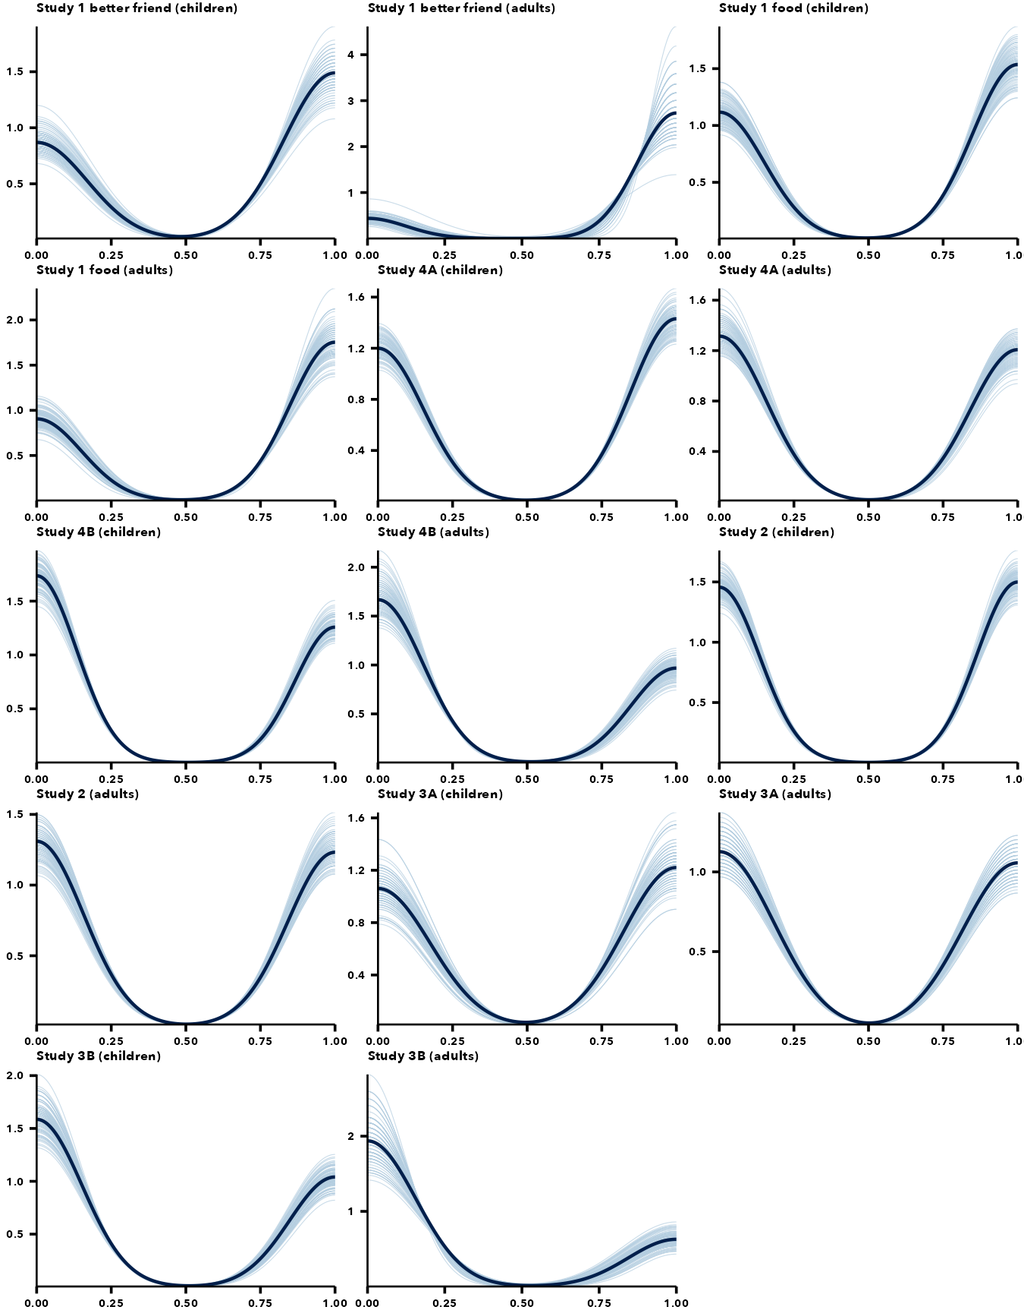
Figure 1: Posterior predictive checks for all models (pp_check, type = “dens_overlay”). In each panel the dark line is the observed distribution and the light lines are 100 draws from the posterior predictive distribution; for the binary outcome the density is bimodal (mass near 0 = fact and 1 = emotion), with peak heights reflecting the proportion choosing each. Observed and predicted align well across models.

4. Full posterior estimates
For each study we report the posterior median, 95% credible interval, percentage of the posterior in the ROPE, and probability of direction for every model term (child models on the probit scale, with age mean-centered so condition terms are evaluated at the mean age).
Table 2: Table S2. Study 1 - full posterior estimates.
Model | Term | Median | 95% CI | % in ROPE | pd
Study 1 <U+2014> better friend (children) | Intercept | -0.02 | [-0.45, 0.41] | 36.5 | 0.540
Study 1 <U+2014> better friend (children) | emotionsad | 1.21 | [0.56, 2.06] | 0.0 | 1.000
Study 1 <U+2014> better friend (children) | age_c | 0.39 | [-0.01, 0.89] | 7.0 | 0.973
Study 1 <U+2014> better friend (children) | emotionsad:age_c | 0.48 | [-0.17, 1.24] | 8.8 | 0.923
Study 1 <U+2014> better friend (adults) | Intercept | 1.05 | [0.55, 1.96] | 0.0 | 1.000
Study 1 <U+2014> better friend (adults) | emotionsad | 0.61 | [-0.10, 1.43] | 5.7 | 0.954
Study 1 <U+2014> food sharing (children) | Intercept | 0.07 | [-0.29, 0.43] | 39.3 | 0.651
Study 1 <U+2014> food sharing (children) | emotionsad | 0.20 | [-0.28, 0.67] | 23.2 | 0.795
Study 1 <U+2014> food sharing (children) | measureice_cream | -0.09 | [-0.57, 0.39] | 29.8 | 0.642
Study 1 <U+2014> food sharing (children) | age_c | -0.04 | [-0.38, 0.31] | 42.0 | 0.582
Study 1 <U+2014> food sharing (children) | emotionsad:measureice_cream | 0.40 | [-0.29, 1.10] | 11.6 | 0.873
Study 1 <U+2014> food sharing (children) | emotionsad:age_c | 0.11 | [-0.36, 0.58] | 29.1 | 0.681
Study 1 <U+2014> food sharing (children) | measureice_cream:age_c | 0.32 | [-0.13, 0.80] | 14.5 | 0.912
Study 1 <U+2014> food sharing (children) | emotionsad:measureice_cream:age_c | -0.40 | [-1.08, 0.26] | 11.6 | 0.881
Study 1 <U+2014> food sharing (adults) | Intercept | -0.19 | [-0.56, 0.17] | 25.5 | 0.854
Study 1 <U+2014> food sharing (adults) | emotionsad | 0.33 | [-0.17, 0.84] | 14.1 | 0.897
Study 1 <U+2014> food sharing (adults) | measureice_cream | 1.02 | [0.48, 1.58] | 0.0 | 1.000
Study 1 <U+2014> food sharing (adults) | emotionsad:measureice_cream | 0.02 | [-0.78, 0.83] | 19.3 | 0.521

Table 3: Table S3. Study 1 food-sharing cell-means model (reference = happy/candy).
Model | Term | Median | 95% CI | % in ROPE | pd
Study 1 cell-means (children) | Intercept | 0.07 | [-0.28, 0.42] | 39.0 | 0.658
Study 1 cell-means (children) | cond4sad_candy | 0.19 | [-0.27, 0.67] | 24.3 | 0.784
Study 1 cell-means (children) | cond4happy_ice_cream | -0.09 | [-0.57, 0.38] | 30.5 | 0.651
Study 1 cell-means (children) | cond4sad_ice_cream | 0.50 | [0.02, 1.00] | 4.3 | 0.979
Study 1 cell-means (adults) | Intercept | -0.19 | [-0.56, 0.17] | 25.1 | 0.847
Study 1 cell-means (adults) | cond4sad_candy | 0.33 | [-0.18, 0.83] | 14.0 | 0.896
Study 1 cell-means (adults) | cond4happy_ice_cream | 1.01 | [0.46, 1.55] | 0.0 | 1.000
Study 1 cell-means (adults) | cond4sad_ice_cream | 1.36 | [0.79, 1.98] | 0.0 | 1.000

Table 4: Table S4. Study 2 (friend vs. best friend) - full posterior estimates.
Model | Term | Median | 95% CI | % in ROPE | pd
Study 2 (children) | Intercept | -0.36 | [-0.66, -0.08] | 3.3 | 0.995
Study 2 (children) | emotionsad | 0.32 | [-0.05, 0.68] | 11.2 | 0.953
Study 2 (children) | relationshipbestfriend | 0.53 | [0.16, 0.90] | 1.1 | 0.998
Study 2 (children) | age_c | -0.14 | [-0.39, 0.11] | 35.7 | 0.859
Study 2 (children) | emotionsad:relationshipbestfriend | -0.11 | [-0.63, 0.42] | 27.1 | 0.655
Study 2 (children) | emotionsad:age_c | -0.22 | [-0.56, 0.11] | 20.4 | 0.908
Study 2 (children) | relationshipbestfriend:age_c | 0.19 | [-0.13, 0.52] | 24.9 | 0.879
Study 2 (children) | emotionsad:relationshipbestfriend:age_c | 0.59 | [0.12, 1.08] | 1.9 | 0.992
Study 2 (adults) | Intercept | -0.59 | [-1.10, -0.11] | 2.0 | 0.992
Study 2 (adults) | emotionsad | 0.83 | [0.26, 1.43] | 0.5 | 0.998
Study 2 (adults) | relationshipbestfriend | -0.01 | [-0.59, 0.58] | 26.2 | 0.515
Study 2 (adults) | emotionsad:relationshipbestfriend | 0.54 | [-0.30, 1.36] | 8.3 | 0.895

Table 5: Table S5. Study 3A - full posterior estimates.
Model | Term | Median | 95% CI | % in ROPE | pd
Study 3A (children) | Intercept | 0.22 | [-0.15, 0.61] | 20.9 | 0.887
Study 3A (children) | emotionsad | -0.25 | [-0.75, 0.25] | 19.4 | 0.844
Study 3A (children) | age_c | 0.02 | [-0.34, 0.39] | 41.3 | 0.551
Study 3A (children) | emotionsad:age_c | 0.36 | [-0.12, 0.84] | 11.7 | 0.928
Study 3A (adults) | Intercept | -0.06 | [-1.48, 1.20] | 14.3 | 0.546
Study 3A (adults) | emotionsad | -0.16 | [-1.09, 0.75] | 16.4 | 0.633

Table 6: Table S6. Study 3B - full posterior estimates.
Model | Term | Median | 95% CI | % in ROPE | pd
Study 3B (children) | Intercept | -0.22 | [-0.57, 0.10] | 20.6 | 0.906
Study 3B (children) | emotionsad | -0.27 | [-0.68, 0.12] | 16.4 | 0.907
Study 3B (children) | age_c | -0.08 | [-0.38, 0.20] | 44.7 | 0.715
Study 3B (children) | emotionsad:age_c | -0.04 | [-0.38, 0.30] | 42.1 | 0.588
Study 3B (adults) | Intercept | -0.57 | [-1.24, -0.12] | 1.7 | 0.993
Study 3B (adults) | emotionsad | -0.68 | [-1.41, -0.07] | 2.8 | 0.986

Table 7: Table S7. Study 4A (child -> mom vs. friend’s mom) - full posterior estimates.
Model | Term | Median | 95% CI | % in ROPE | pd
Study 4A (children) | Intercept | -0.05 | [-0.45, 0.36] | 37.3 | 0.591
Study 4A (children) | emotionsad | -0.31 | [-0.82, 0.19] | 15.0 | 0.890
Study 4A (children) | relationshipmom | 0.19 | [-0.31, 0.69] | 23.3 | 0.771
Study 4A (children) | age_c | -0.26 | [-0.68, 0.13] | 17.2 | 0.911
Study 4A (children) | emotionsad:relationshipmom | 1.12 | [0.36, 1.90] | 0.3 | 0.998
Study 4A (children) | emotionsad:age_c | 0.19 | [-0.30, 0.69] | 23.2 | 0.777
Study 4A (children) | relationshipmom:age_c | 0.43 | [-0.06, 0.93] | 8.2 | 0.954
Study 4A (children) | emotionsad:relationshipmom:age_c | 0.25 | [-0.48, 1.02] | 16.9 | 0.749
Study 4A (adults) | Intercept | -0.69 | [-1.17, -0.25] | 0.5 | 0.999
Study 4A (adults) | emotionsad | -0.37 | [-0.99, 0.22] | 12.7 | 0.889
Study 4A (adults) | relationshipmom | 1.18 | [0.62, 1.77] | 0.0 | 1.000
Study 4A (adults) | emotionsad:relationshipmom | 0.85 | [0.02, 1.73] | 2.8 | 0.977

Table 8: Table S8. Study 4B (mom / friend’s mom -> child) - full posterior estimates.
Model | Term | Median | 95% CI | % in ROPE | pd
Study 4B (children) | Intercept | -0.27 | [-0.57, 0.04] | 13.0 | 0.957
Study 4B (children) | emotionsad | -0.15 | [-0.54, 0.23] | 30.0 | 0.784
Study 4B (children) | relationshipmom | -0.06 | [-0.44, 0.31] | 37.5 | 0.636
Study 4B (children) | age_c | 0.23 | [-0.04, 0.50] | 16.7 | 0.956
Study 4B (children) | emotionsad:relationshipmom | 0.48 | [-0.04, 1.02] | 6.3 | 0.963
Study 4B (children) | emotionsad:age_c | -0.45 | [-0.80, -0.12] | 1.9 | 0.996
Study 4B (children) | relationshipmom:age_c | 0.05 | [-0.28, 0.39] | 41.8 | 0.621
Study 4B (children) | emotionsad:relationshipmom:age_c | 0.35 | [-0.12, 0.82] | 11.7 | 0.929
Study 4B (adults) | Intercept | -0.54 | [-1.01, -0.09] | 2.7 | 0.991
Study 4B (adults) | emotionsad | -0.14 | [-0.71, 0.41] | 24.7 | 0.681
Study 4B (adults) | relationshipmom | 0.39 | [-0.15, 0.95] | 10.8 | 0.922
Study 4B (adults) | emotionsad:relationshipmom | 0.02 | [-0.75, 0.79] | 19.0 | 0.513

5. One-sided binomial tests (all cells)
Table 9: Table S9. One-sided Bayesian binomial tests vs chance, in the pre-registered direction. BF10 favors the hypothesized direction; BF01 favors the null.
Study | Population | Cell | Emotion | % emotion | Direction | BF10 | BF01
study1 | adult | Better friend | Happy | 81 | emotion | 3151.98 | 0.00
study1 | adult | Better friend | Sad | 91 | emotion | 9514663.40 | 0.00
study1 | adult | Candy | Happy | 43 | emotion | 0.18 | 5.56
study1 | adult | Candy | Sad | 55 | emotion | 0.65 | 1.54
study1 | adult | Ice cream | Happy | 79 | emotion | 947.34 | 0.00
study1 | adult | Ice cream | Sad | 87 | emotion | 245139.75 | 0.00
study1 | child | Better friend | Happy | 49 | emotion | 0.28 | 3.57
study1 | child | Better friend | Sad | 77 | emotion | 1830.40 | 0.00
study1 | child | Candy | Happy | 53 | emotion | 0.43 | 2.33
study1 | child | Candy | Sad | 60 | emotion | 1.49 | 0.67
study1 | child | Ice cream | Happy | 49 | emotion | 0.28 | 3.57
study1 | child | Ice cream | Sad | 70 | emotion | 45.08 | 0.02
study2 | adult | Best friend | Happy | 33 | emotion | 0.10 | 10.00
study2 | adult | Best friend | Sad | 71 | emotion | 40.21 | 0.02
study2 | adult | Friend | Happy | 33 | emotion | 0.10 | 10.00
study2 | adult | Friend | Sad | 57 | emotion | 0.86 | 1.16
study2 | child | Best friend | Happy | 55 | emotion | 0.71 | 1.41
study2 | child | Best friend | Sad | 62 | emotion | 6.48 | 0.15
study2 | child | Friend | Happy | 38 | emotion | 0.07 | 14.29
study2 | child | Friend | Sad | 48 | emotion | 0.18 | 5.56
study3A | adult | Create | Happy | 49 | emotion | 0.31 | 3.23
study3A | adult | Create | Sad | 48 | emotion | 0.28 | 3.57
study3A | child | Create | Happy | 58 | emotion | 1.03 | 0.97
study3A | child | Create | Sad | 49 | emotion | 0.28 | 3.57
study3B | adult | Deepen | Happy | 33 | emotion | 0.10 | 10.00
study3B | adult | Deepen | Sad | 16 | emotion | 0.06 | 16.67
study3B | child | Deepen | Happy | 44 | emotion | 0.11 | 9.09
study3B | child | Deepen | Sad | 36 | emotion | 0.06 | 16.67
study4A | adult | Friend’s mom | Happy | 28 | emotion | 0.09 | 11.11
study4A | adult | Friend’s mom | Sad | 19 | emotion | 0.07 | 14.29
study4A | adult | Mom | Happy | 66 | emotion | 5.65 | 0.18
study4A | adult | Mom | Sad | 79 | emotion | 947.34 | 0.00
study4A | child | Friend’s mom | Happy | 49 | emotion | 0.28 | 3.57
study4A | child | Friend’s mom | Sad | 39 | emotion | 0.12 | 8.33
study4A | child | Mom | Happy | 54 | emotion | 0.56 | 1.79
study4A | child | Mom | Sad | 75 | emotion | 641.15 | 0.00
study4B | adult | Friend’s mom | Happy | 33 | fact | 9.40 | 0.11
study4B | adult | Friend’s mom | Sad | 29 | fact | 40.21 | 0.02
study4B | adult | Mom | Happy | 45 | fact | 0.63 | 1.59
study4B | adult | Mom | Sad | 41 | fact | 1.23 | 0.81
study4B | child | Friend’s mom | Happy | 42 | fact | 1.70 | 0.59
study4B | child | Friend’s mom | Sad | 37 | fact | 17.04 | 0.06
study4B | child | Mom | Happy | 40 | fact | 3.53 | 0.28
study4B | child | Mom | Sad | 50 | fact | 0.24 | 4.17

6. Social-closeness (circles) measure
In addition to the binary forced-choice items, in Study 1 (pre-registration Part 1) children and adults rated how close each character was to the protagonist on a six-step overlapping-circles scale (the Inclusion of Other in the Self measure; Aron et al. (1992)). In the raw data the most-overlapping (“closest”) option was coded 1 and the fully-separate (“least close”) option 6; we reverse-scored the ratings (7 − rating) so that higher = closer in all analyses below. This was a pre-registered dependent variable for Study 1; we report it here because it was not included in the main text due to children seemingly insensitive to the measure in either pilot or the full sample.
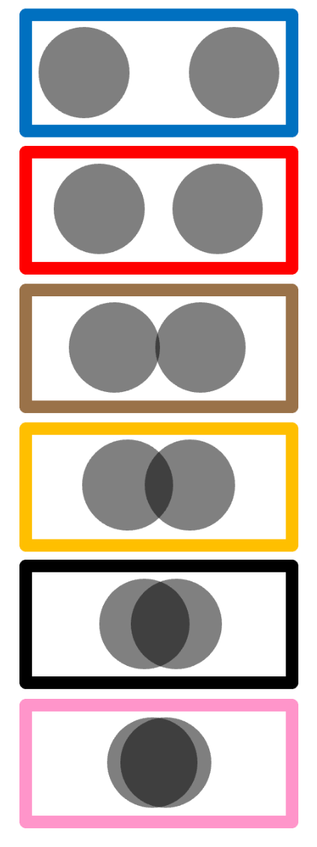
Figure 2: The six-step social-closeness (circles) scale shown to children (the actual stimulus from the pre-registration), adapted from the Inclusion of Other in the Self measure (Aron et al., 1992). Children chose the option whose two circles best represented how close two characters were, ranging from fully separate (least close) to almost fully overlapping (closest). In the raw data these extremes were coded 6 and 1, respectively; analyses below reverse-score the ratings so that higher = closer.
Scale comprehension. Two checks indicate children used the scale appropriately. First, on the three warm-up items they placed different relationships sensibly — rating strangers as least close, a parent and child as closest, and friends in between. Second, and more directly relevant to the subtler classmate contrast, children’s circle ratings tracked their own forced choices: the classmate they selected as the better friend (and as the ice-cream partner) received the closer circle rating. The circles thus reflect the same closeness judgement as the binary items. (The warm-ups, however, only calibrate gross relationship distinctions; they do not include a fine, same-tier contrast such as friend vs. best friend, so the graded results below are best read as suggestive support for the binary findings.)
Following the pre-registration, we analyzed the (reverse-scored) ratings with a Bayesian linear mixed-effects model, closeness ~ target * condition + (1 | ID), where target is the classmate who was told the emotion vs. the fact and condition is the happy vs. sad vignette. Descriptively, in the sad condition the emotion-classmate was rated closer than the fact-classmate, whereas in the happy condition the two were equivalent (Table S10) — the same pattern as the “better friend” choice in the main text.
Table 10: Table S10. Mean social-closeness (circles) ratings (reverse-scored, higher = closer) by population, condition, and which character was told the emotion vs. the fact (children N = 57, adults N = 47).
Population | Condition | Character told | Mean closeness | SD | N
Children | Happy | Fact | 2.84 | 1.37 | 57
Children | Happy | Emotion | 2.88 | 1.39 | 57
Children | Sad | Fact | 2.49 | 1.24 | 57
Children | Sad | Emotion | 2.89 | 1.47 | 57
Adults | Happy | Fact | 3.32 | 0.98 | 47
Adults | Happy | Emotion | 4.19 | 0.99 | 47
Adults | Sad | Fact | 3.02 | 0.94 | 47
Adults | Sad | Emotion | 4.30 | 0.91 | 47

In the model, the target × condition interaction was in the predicted direction — the emotion-classmate advantage was larger in the sad condition (median = 0.37, 95% CI [-0.18, 0.91]) — although its 95% credible interval included zero; the two targets did not differ in the happy condition (median = 0.03, 95% CI [-0.34, 0.43]). Thus the graded measure points the same way as the binary “better friend” judgement, more weakly. Full estimates are in Table S11 and the means are plotted in Figure 3.
For adults, who completed the same circle scale, we could recover the emotion- vs. fact-target mapping because the adult study used a single fixed survey version: each character’s name was perfectly confounded with the role it played, which we confirmed against adults’ better-friend choices and free-text justifications. Coded this way, adults rated the emotion-character as markedly closer than the fact-character — a credible main effect of target (median = 0.87, 95% CI [0.52, 1.23]) — in both the happy and sad conditions; the target × condition interaction was not credible (median = 0.40, 95% CI [-0.11, 0.90]). On the graded scale, then, adults showed the same emotion-disclosure → closeness inference as in their forced-choice judgements, and more clearly than children did.
Table 11: Table S11. Social-closeness (circles) model: posterior estimates (linear model on the reverse-scored 1-6 scale, higher = closer; reference = fact-target, happy condition).
Population | Term | Median | 95% CI | % in ROPE | pd
Children | Intercept | 2.85 | [2.48, 3.20] | 0.0 | 1.000
Children | targetemo | 0.03 | [-0.34, 0.43] | 38.9 | 0.569
Children | emotionsad | -0.35 | [-0.73, 0.04] | 9.2 | 0.962
Children | targetemo:emotionsad | 0.37 | [-0.18, 0.91] | 12.6 | 0.908
Adults | Intercept | 3.32 | [3.03, 3.60] | 0.0 | 1.000
Adults | targetemo | 0.87 | [0.52, 1.23] | 0.0 | 1.000
Adults | emotionsad | -0.30 | [-0.65, 0.06] | 12.3 | 0.950
Adults | targetemo:emotionsad | 0.40 | [-0.11, 0.90] | 9.2 | 0.939

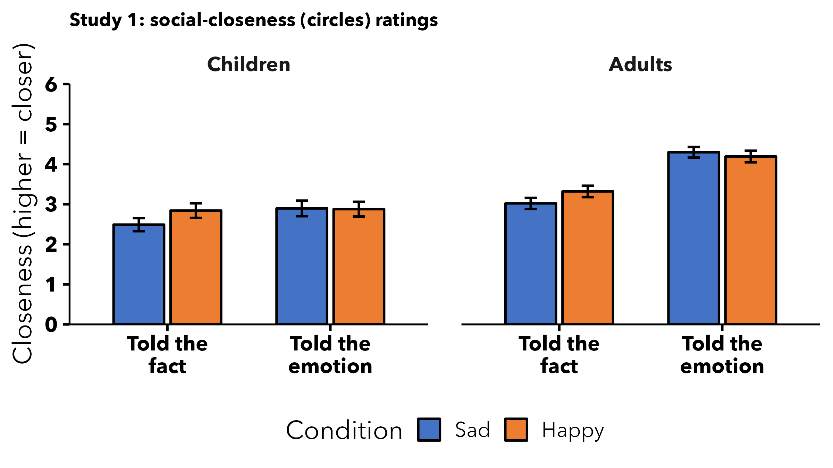
Figure 3: Mean social-closeness (circles) ratings (reverse-scored; higher = closer) for the character who was told the emotion vs. the fact, by condition, for children and adults. Error bars = ±1 SE. Consistent with the binary ‘better friend’ choice, the emotion-character is rated closer (children: in the sad condition; adults: in both conditions).
In short, the graded circles measure corroborates the binary results. For children, the emotion-character was rated closer (most clearly in the sad condition), mirroring their “better friend” choices, though the effect was suggestive rather than credible (its 95% credible interval included zero) — plausibly because the warm-ups did not calibrate fine, same-tier distinctions. For adults, the emotion-character was rated credibly closer, converging with the forced-choice results.

6.1 Developmental change
We refit the (reverse-scored) closeness model with mean-centred continuous age folded in, closeness ~ target * emotion * age + (1 | ID). There was no credible developmental change: the main effect of age was null (median = 0.09, 95% CI [-0.25, 0.44]), as were the age × target interaction (median = 0.11, 95% CI [-0.25, 0.47]) and the age × condition interaction (median = -0.19, 95% CI [-0.55, 0.17]). The three-way target × condition × age interaction trended positive (median = 0.41, 95% CI [-0.10, 0.92]): descriptively, the tendency to rate the emotion-classmate as closer specifically in the sad condition strengthened with age (Figure 4), but its 95% credible interval included zero, so we interpret it cautiously. This direction nonetheless mirrors the developmental pattern in Study 2, where the sad-emotion preference for a best friend also grew with age.
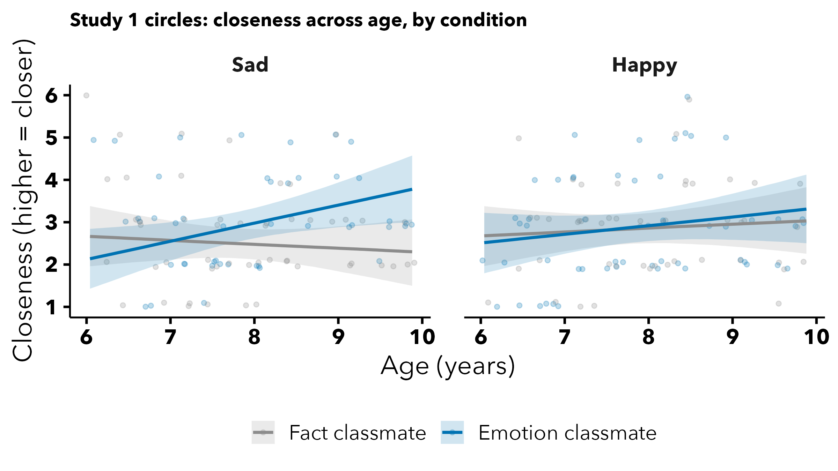
Figure 4: Study 1 circles, developmental. Model-predicted closeness (reverse-scored; higher = closer) across age for the classmate told the emotion vs. the fact, by condition (children). Bands = 95% credible intervals; points = individual ratings (jittered).

7. Gender effects
As an exploratory, non-pre-registered check, we tested whether the child’s gender moderated the results (gender was reported by the caregiver). For each study we refit the child probit model adding the child’s gender and its interaction with emotion (chose_emotion ~ emotion * gender + (1 | ID)), collapsing across the relationship/measure factors so the test is uniform across studies. Models compare boys to girls (the reference); the single child whose caregiver reported a non-binary gender (Set B/C) was dropped because a one-child group cannot be estimated. As elsewhere, we treat a term as credible when its 95% credible interval excludes zero.
Across the seven studies, none of the 14 gender-related terms (a gender main effect and a gender x emotion interaction per study) had a 95% credible interval excluding zero. We therefore found no evidence that boys and girls differed in their judgements.
Table 12: Table S12. Exploratory gender effects: posterior estimates for the child’s gender and its interaction with emotion, by study (probit scale; reference = girls, happy condition).
Study | Term | Median | 95% CI | % in ROPE | pd
Study 1 - better friend | Boys (vs. girls) | 0.19 | [-0.59, 0.98] | 17.6 | 0.676
Study 1 - better friend | Boys x sad | -0.13 | [-1.18, 0.89] | 15.1 | 0.600
Study 1 - food sharing | Boys (vs. girls) | 0.02 | [-0.38, 0.42] | 37.3 | 0.540
Study 1 - food sharing | Boys x sad | 0.01 | [-0.52, 0.54] | 29.3 | 0.513
Study 2 | Boys (vs. girls) | -0.22 | [-0.58, 0.14] | 21.5 | 0.887
Study 2 | Boys x sad | 0.28 | [-0.15, 0.71] | 16.6 | 0.900
Study 3A | Boys (vs. girls) | 0.34 | [-0.33, 1.01] | 13.9 | 0.841
Study 3A | Boys x sad | -0.81 | [-1.67, 0.02] | 2.9 | 0.973
Study 3B | Boys (vs. girls) | -0.48 | [-1.10, 0.15] | 8.3 | 0.931
Study 3B | Boys x sad | 0.68 | [-0.05, 1.45] | 4.1 | 0.967
Study 4A | Boys (vs. girls) | -0.18 | [-0.58, 0.23] | 26.7 | 0.809
Study 4A | Boys x sad | 0.13 | [-0.39, 0.63] | 26.3 | 0.686
Study 4B | Boys (vs. girls) | -0.15 | [-0.52, 0.23] | 30.2 | 0.779
Study 4B | Boys x sad | 0.18 | [-0.27, 0.63] | 25.4 | 0.783

8. References
Aron, A., Aron, E. N., & Smollan, D. (1992). Inclusion of other in the self scale and the structure of interpersonal closeness. Journal of Personality and Social Psychology, 63(4), 596–612. https://doi.org/10.1037/0022-3514.63.4.596
Gelman, A., Goodrich, B., Gabry, J., & Vehtari, A. (2019). R-squared for Bayesian regression models. The American Statistician, 73(3), 307–309. https://doi.org/10.1080/00031305.2018.1549100
Vasishth, S., Yadav, H., Schad, D. J., & Nicenboim, B. (2023). Sample size determination for Bayesian hierarchical models commonly used in psycholinguistics. Computational Brain & Behavior, 6(1), 102–126.
Wagenmakers, E.-J., Gronau, Q. F., & Vandekerckhove, J. (2019). Five bayesian intuitions for the stopping rule principle.
Woo, B. M., Yu, E., & Thomas, A. J. (2024). Children expect people to accurately represent the minds of their close social partners. Proceedings of the Annual Meeting of the Cognitive Science Society, 46. https://escholarship.org/uc/item/75m9c4b3

